Steve Miller – The Joker

[Verse/Chorus] F | Bb | C
Extra bars of C at end of chorus

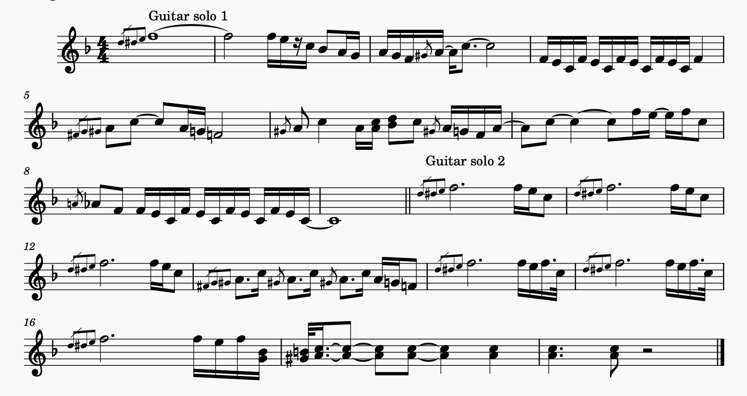
2 verse, chorus, guitar solo, verse, chorus, guitar solo, verse, verse with fadeout

